# **6115- MAHENDRA INSTITUTE OF ENGINEERING AND** TECHNOLOGY

**PUBLIC TRANSPORTATION AND OPTIMIZATION**

* **Public Transportation Optimization in IoT**

**The integration of IoT in public transportation systems can revolutionize the way we move. With efficient route planning and real-time monitoring, public transportation can become more convenient and reliable. Let's take a look at the benefits of optimizing public transportation through IoT and some examples of IoT solutions.**

* **The Importance of Public Transportation :**

**1.Cost-effective:**

**Public transportation can be more affordable than driving or taking a taxi.**

**2.Reduced traffic congestion:**

**When more people use public transportation, there are fewer cars on the road, leading to less traffic and pollution.**

**3.Accessibility :**

**Public transportation provides an accessible means of travel for those who may not be able to afford a car or are unable**

# **Existing system :**

**Optimizing public transportation systems typically involves various strategies and technologies to improve efficiency, accessibility, and sustainability. Some existing approaches include:**

* **Real-time Tracking:**

**Implementing GPS and tracking systems to monitor vehicles in real-time, helping passengers know when their ride will arrive.**

* **Data Analytics:**

**Analyzing passenger data to optimize routes, schedules, and capacity to meet demand more effectively.**

* **Multimodal Integration:**

**Integrating different modes of transportation (e.g., buses, trains, subways, and rideshares) to create a seamless network.**

* **Smart Ticketing:**

**Using contactless payment methods and mobile apps for ticketing to reduce boarding times and streamline fare collection.**

**Designating dedicated lanes for public transit to reduce congestion and improve travel times.**

* **Electric and Sustainable Vehicles:**

**Transitioning to electric or hybrid vehicles to reduce emissions and environmental impact.**

* **Accessibility Improvements:**

**Ensuring that public transportation is accessible to people with disabilities and those with limited mobility.**

* **Public-Private Partnerships:**

**Collaborating with private companies for innovative solutions and funding.**

* **Demand-Responsive Transit:**

**Implementing on-demand services in areas with variable ridership patterns.**

* **Public Engagement:**

**Involving the community in the decision-making process and gathering feedback to make informed improvements.**

**These strategies can vary depending on the specific needs and challenges of a particular public transportation syste**

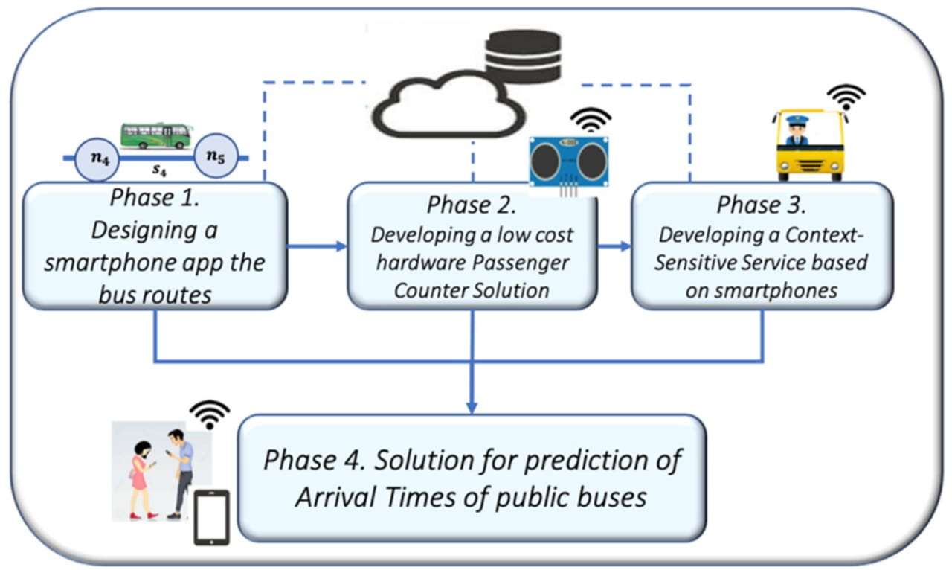

* **proposed system**

**Designing a proposed system for optimizing public transportation involves considering various factors to enhance efficiency, accessibility, and sustainability. Here's a high-level overview of a potential system**

**Implement a centralized system that collects and analyzes real-time data from buses, trains, subways, and other transit modes. This data should include passenger counts, vehicle locations, and traffic condition.**

* **Passenger Information Systems:**

**Develop a mobile app and digital signage at stops/stations to provide passengers with real-time updates on arrival times, delays, and service disruptions. Include trip planning features for multimodal journeys.**

* **Fare Integration:**

**Implement a unified fare payment system that allows passengers to use a single payment method (e.g., contactless cards, mobile apps) across all transit modes, reducing boarding times and administrative costs.**

* **Transit Priority Infrastructure:**

**Create dedicated bus lanes, transit signal priority systems, and bus rapid transit (BRT) routes to ensure that public transit moves efficiently through traffic.**

* **Electric and Sustainable Fleet:**

**T ransition to electric and low-emission vehicles to reduce environmental impact. Consider investing in renewable energy sources for charging infrastructure.**

* **Accessibility Focus:**

**Ensure that all transit stations, vehicles, and information systems are accessible to people with disabilities. This includes ramps, elevators, and Braille signage.**

* **Community Engagement:**

**Involve the community in the planning and decision-making process. Collect feedback through surveys, town hall meetings, and digital platforms to address specific needs.**

* **Dynamic Pricing:**

**Implement dynamic pricing models that adjust fares based on demand, time of day, and occupancy rates to encourage off-peak travel and optimize revenue.**

* **Public-Private Partnerships:**

**Collaborate with private companies to enhance services, such as integrating rideshare and bike-sharing options into the transit system.**

* **Environmental Sustainability:**

**Invest in eco-friendly practices such as energy-efficient stations, green infrastructure, and renewable energy sources to reduce the system's carbon footprint**

* **Safety and Security:**

**Enhance security measures on public transit, including surveillance cameras, emergency call buttons, and personnel presence to ensure passenger safety.**

* **Maintenance and Upkeep:**

**Establish a rigorous maintenance schedule for vehicles and infrastructure to minimize downtime and ensure the system operates reliably.**

* **Data Analytics for Predictive Maintenance:**

**Use predictive analytics to identify maintenance needs in advance, reducing unplanned service interruptions.**

* **Scalability and Flexibility:**

**Design the system with scalability in mind to accommodate future growth and changes in demand.**

* **Promotion and Education:**

**Launch marketing campaigns to promote public transit use and educate the public about the benefits of the optimized system.**

**Implementing such a system requires collaboration among government agencies, transit authorities, technology providers, and the community.**

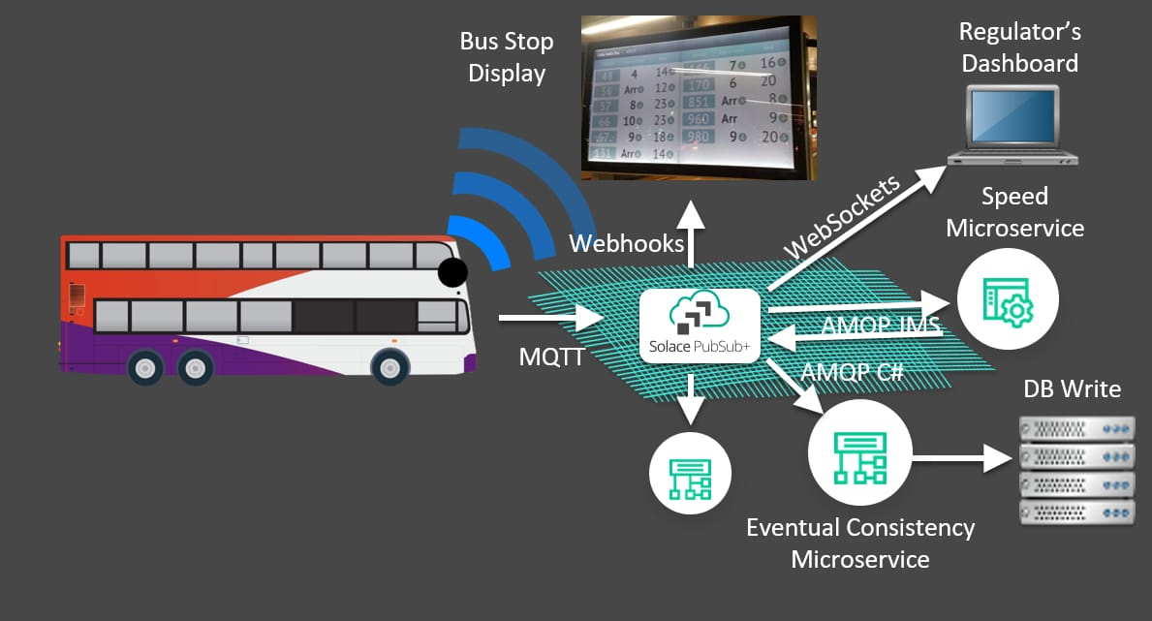

* **Public transportation optimization in proposed system design**
* **Route Planning:**

**Design efficient routes that serve high-demand areas, reduce travel time, and minimize congestion.**

* **Scheduling:**

**Develop timetables that balance frequency and capacity during peak and off-peak hours.**

* **Fleet Management:**

**Optimize the number and types of vehicles based on demand, fuel efficiency, and environmental impact.**

* **Safety:**

**Enhanced security measures can make public transportation safer for passengers, reducing crime and accidents.**

* **Ticketing and Payment Systems:**

**Implement digital payment methods to streamline fare collection and reduce boarding time.**

* **Integration:**

**Ensure seamless connections with other modes of transportation (e.g., buses, trains, subways) to provide a holistic transit system.**

* **Accessibility:**

**Design stations and vehicles to be accessible to people with disabilities.**

* **Information Systems:**

**Provide real-time information to passengers about arrival times and service disruptions through mobile apps and displays at stops.**

* **Environmental Sustainability:**

**Incorporate eco-friendly technologies like electric buses and renewable energy sources.**

* **Data Analytics:**

**Utilize data analysis to monitor performance, identify bottlenecks, and make data-driven improvements.**

* **Safety and Security:**

**Implement measures to ensure passenger safety and reduce crime on public transportation**

**\*\*\*\*THANKYOU\*\*\*\***